|  |  |
| --- | --- |
| Team Member Full Name | NetID |
|  |  |
|  |  |
|  |  |

# Chosen Technology Stack

|  |  |
| --- | --- |
| Python + Django | Python + TkInter |

# Features Implemented for Phase 1

* Feature A
* Feature B
* Feature C
* …

# Demonstration of the Features Implemented for Phase 1

*It should have at least one screenshot per feature*

## Feature A

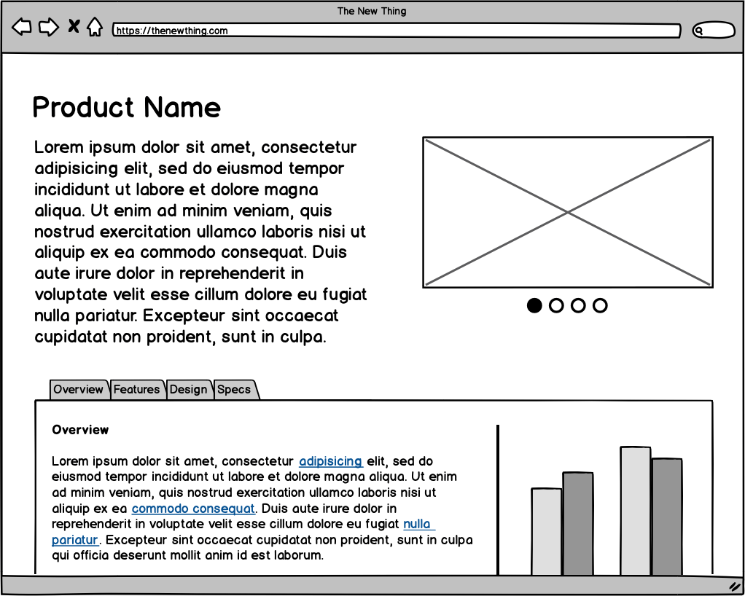

Figure 1 Screenshot for feature A showing ...

## Feature B

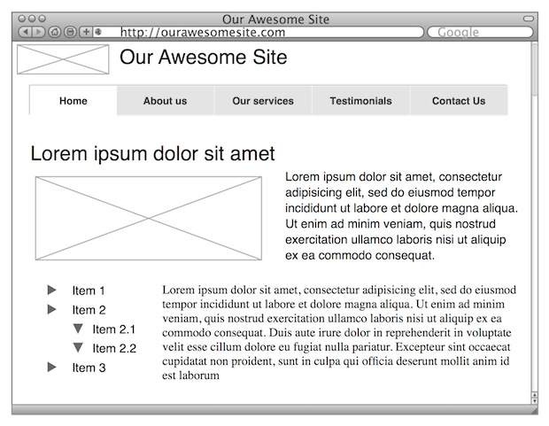

Figure 2 screenshot for feature B

## Feature C

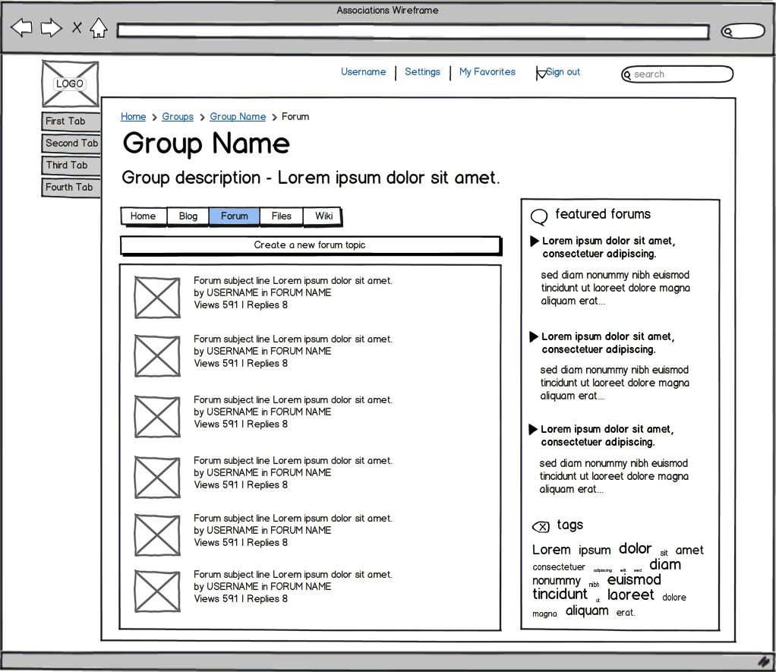

Figure 3 screenshot for feature C